ASSYMETRIC BIPOLAR PULSED-DC POWER SUPPLY
+40V to -800V Pulsed-DC, 50W to 5kW

This series of power supplies generate alternate pulses of opposite polarities. The output voltage, pulse width and the pulse frequency are all controllable through 10 turn potentiometers and switches.

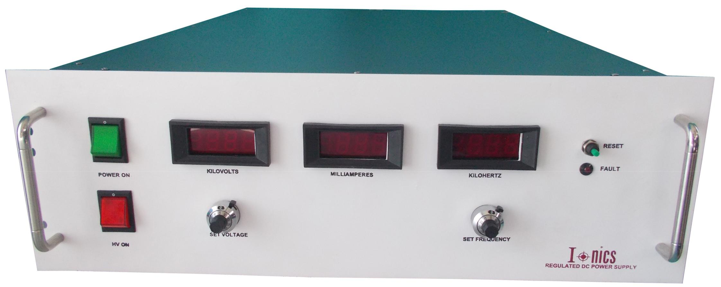
Features:
- Pulsed & Continuous
- Regulated
- Frequency & Duty Cycle Controllable
- 19” Rack Mountable

Technical Specifications
PARAMETER | SPECIFICATION
Input Voltage | 230V ±10% AC, 50Hz, single phase for output power ≤ 2kW  415V ±10% AC, 50Hz, three phase for output power > 2kW
Output Voltage Range* | +40 to -800V DC in pulsed mode (variable)  0 to -800V DC in continuous mode (variable)
Output Power Range* | 50W to 5kW
Frequency Range* | 1kHz to 100kHz
Frequency Control Range | Minimum to maximum of rated frequency range
Duty Cycle Control Range in Pulsed Mode* | 10% to 45% variable (A 10V signal is provided at the back panel for measurement with an external oscilloscope)
Mode of Operation | Pulsed or continuous
Regulating Mode | Constant voltage – Constant current
Voltage, Current, Frequency & Duty Cycle Control | By 10-turn potentiometers on the front panel
Protections* | Against over load, short-circuit and arc
Front Panel | Power ON/OFF switch / MCB with indication  3½ digit voltage, current and frequency meters  10-turn potentiometers for voltage, current, frequency and duty cycle control selector switch for pulse mode or continuous mode selection  Constant voltage – constant current mode indication  Pulse mode- continuous mode indication
Back Panel | Socket for mains input with 250V, 10A 3 conductor power cord of 1.5 meters  / Terminal blocks for 3 phase input  Fuse holder with fuse  BNC connector to measure duty ratio with an external oscilloscope  Terminal for HV output with 10ft of detachable high voltage cable Stud for grounding the unit
Topology | High frequency resonant / PWM-controlled switch mode
Switching Device | IGBT
Cabinet | 19” rack, powder coated, 3U to 5U depending on power rating
- OEM Customization Available
*Optional. To be specified by the user.

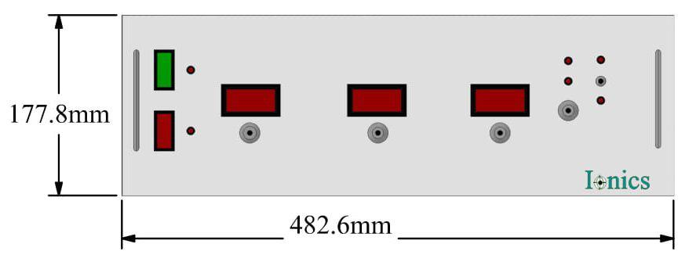
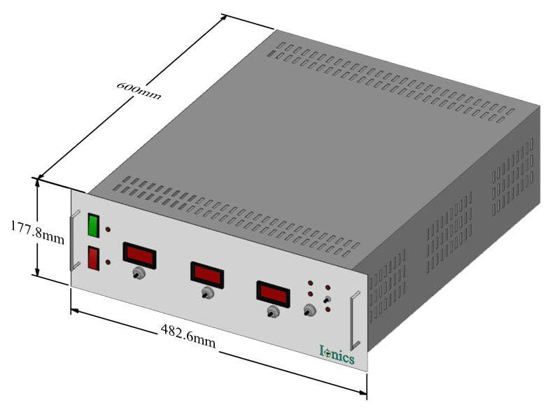

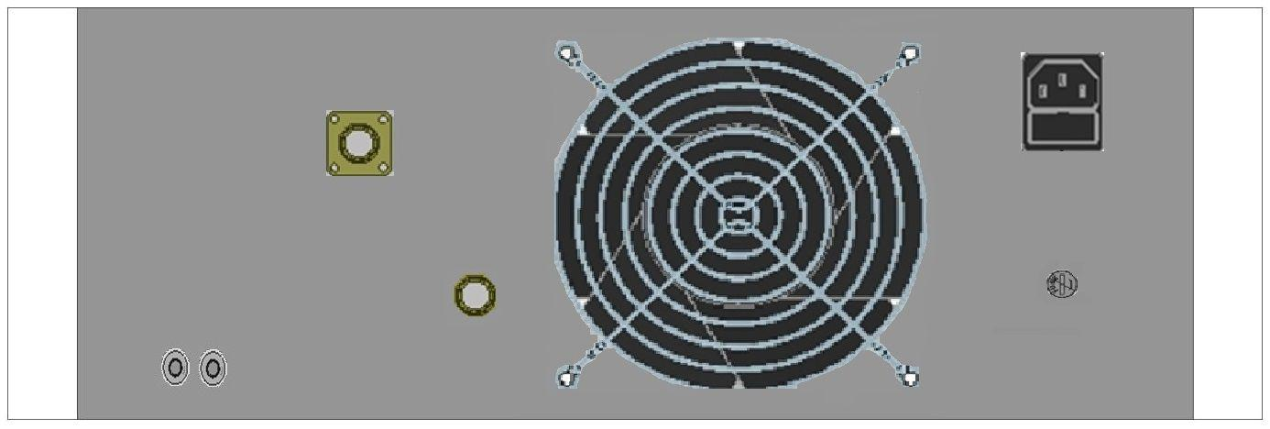

For any queries or customization requests contact us at info@ionics.co.in
For product line information visit us at www.ionics.co.in

